How does the diversity within a closely related group of organisms affect the outcome of their co-culture?

1. During the initial contact (strains that had been separated and grown axenically in the lab for thousands of generations)
2. After the strains have “spent time together”, potentially adapting/acclimating to living together under different environmental conditions.

Pro cannot live alone – they need interactions to survive

Main observations:

1. During the initial contact
   1. Large difference between 9313 to all others (only 9313 is inhibited)

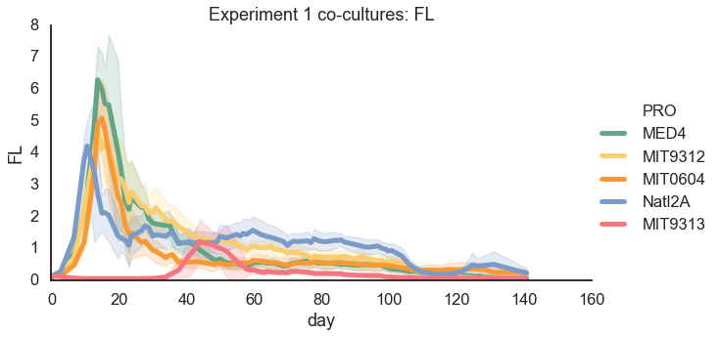

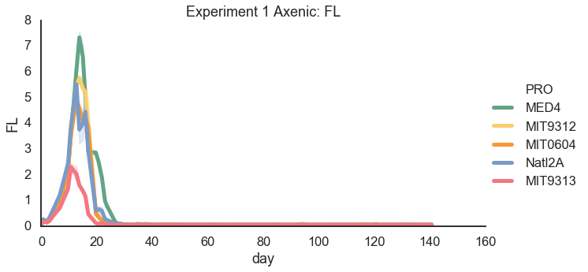

* 1. More subtle differences between other strains (i.e. can differentiate between them in a PCA). No clear differences between Alteromonas

**PCA experiment 1 (ALT/PRO) * change symbol between 1A3 and DE (so DE1 and DE are similar)**

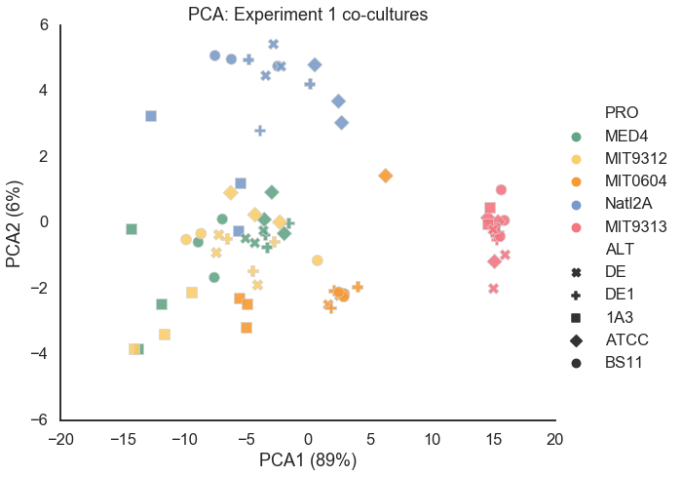

* 1. The main differences are during the late stages (long term starvation) in the dynamics of decrease and in the final (not really steady-state) FL

**Important days e1: aligned to max, not aligned**

**e1 AUC/mean decline bar chart**

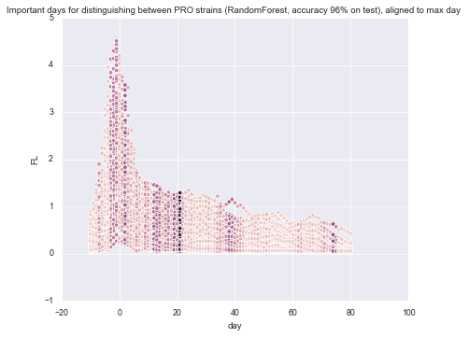

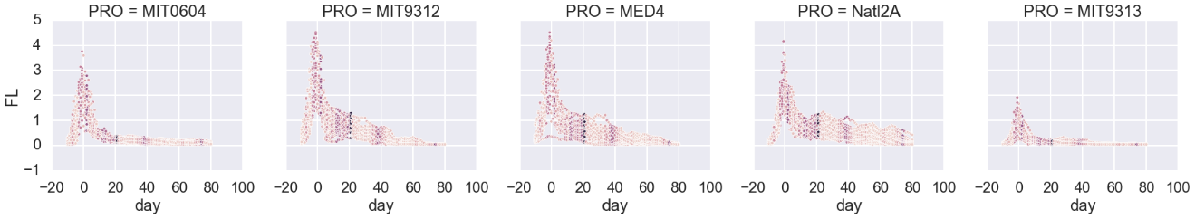

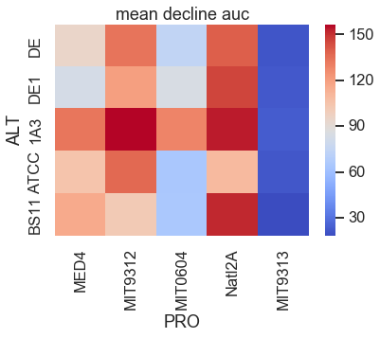

Figure: all growth curves (log-transformed) from exp 1

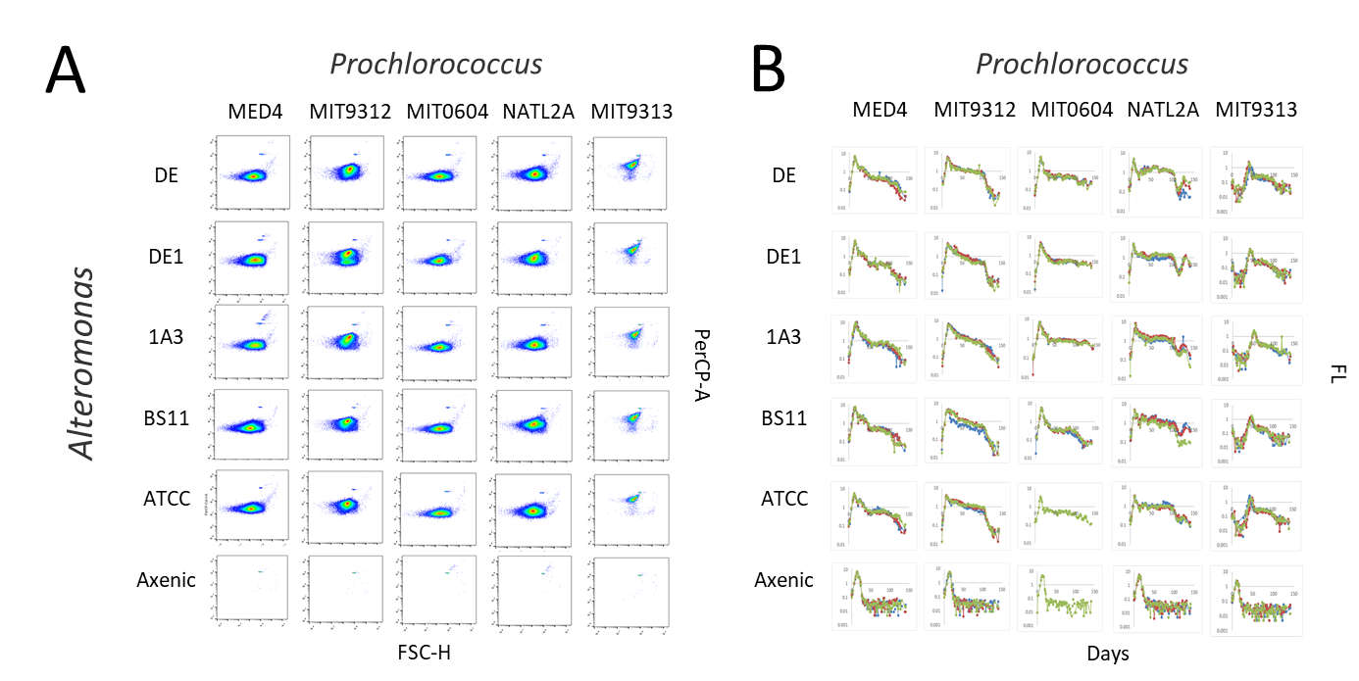

1. Flow cytometry scattergrams of all PRO cultures. The samples were taken from experiment 1 after 100 days of co-culture including axenic and co-culture strains.
2. Bulk culture fluorescence curves over 140 days (experiment 1) are highly consistent between replicates (colors) and differ between strains.

PCA of cell numbers, counted by flow cytometer, of PRO and ALT after 100 days in co-culture – Osnat

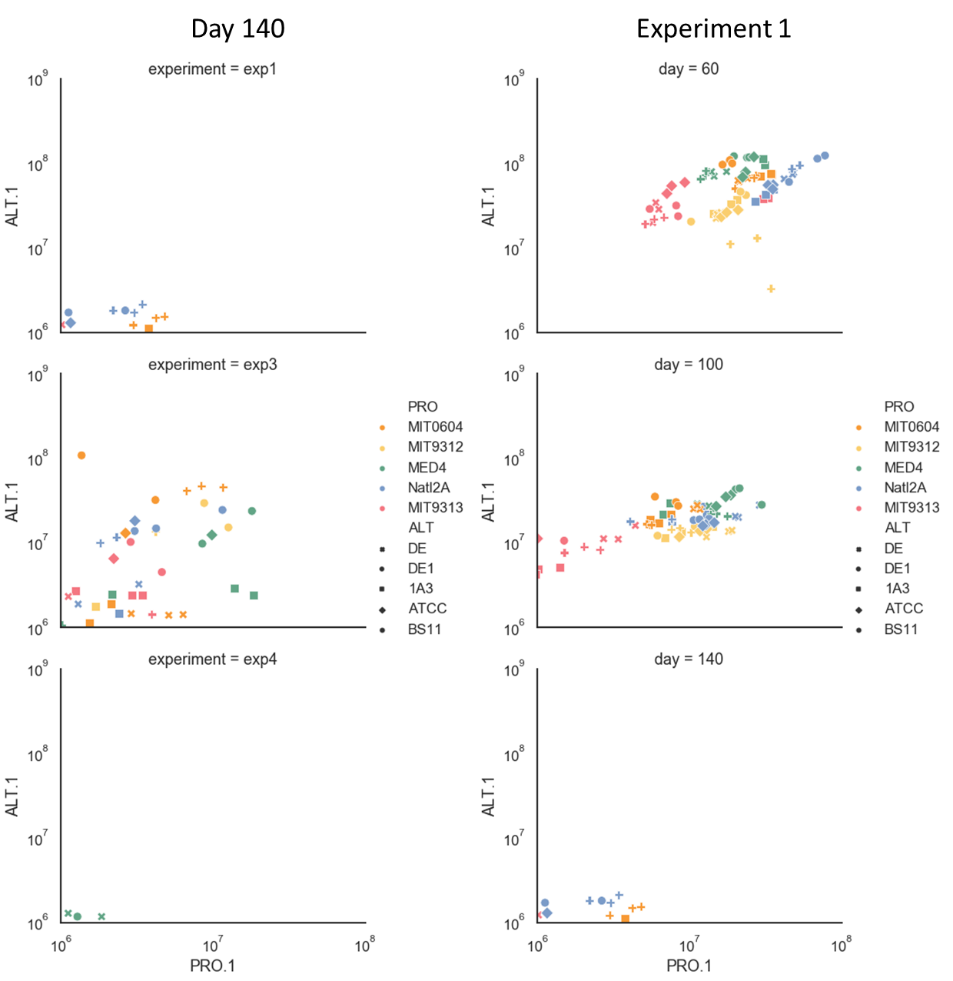

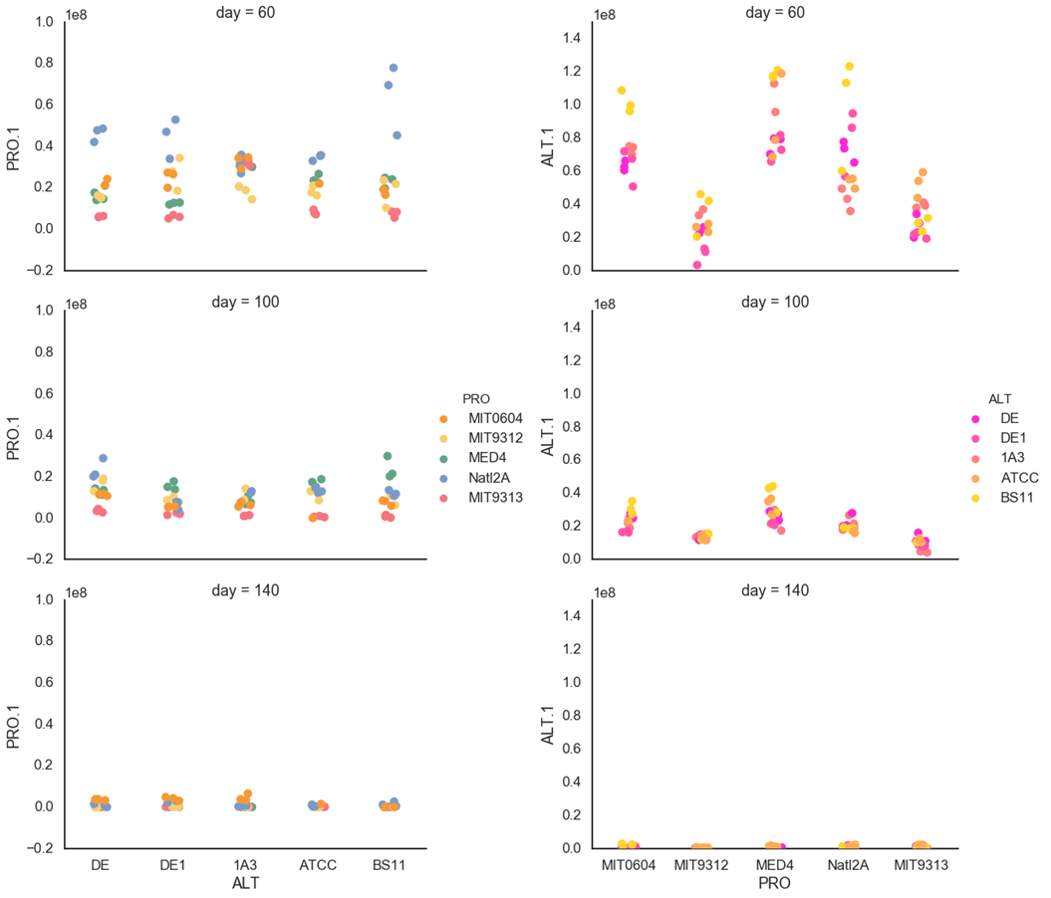

1. What happens during subsequent transfers?
   1. Only Pro that grow with Alt survive. This includes 9313 that was initially inhibited by all Alts. They survive for at least 140 days. ** what happens after 140 days? Look at results of transfers after 185 and 220 days.
   2. No inhibition of 9313 in subsequent transfers (consistent with previous studies – inhibition is dose-dependent)

**All 9313 – show line side by side 1A3 – e1, 3, 4, 5, 6 *Maybe show panels for other Pro strains one above the other\*\***

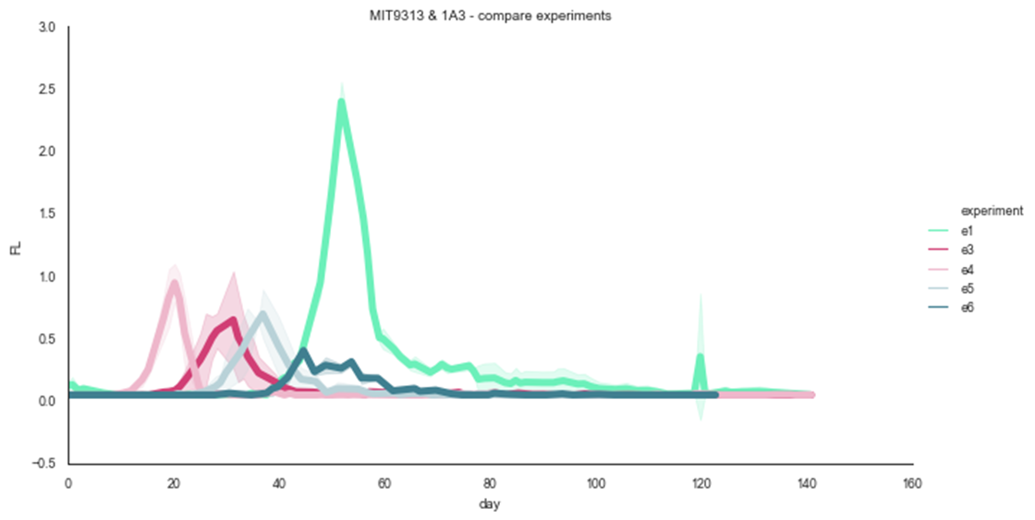

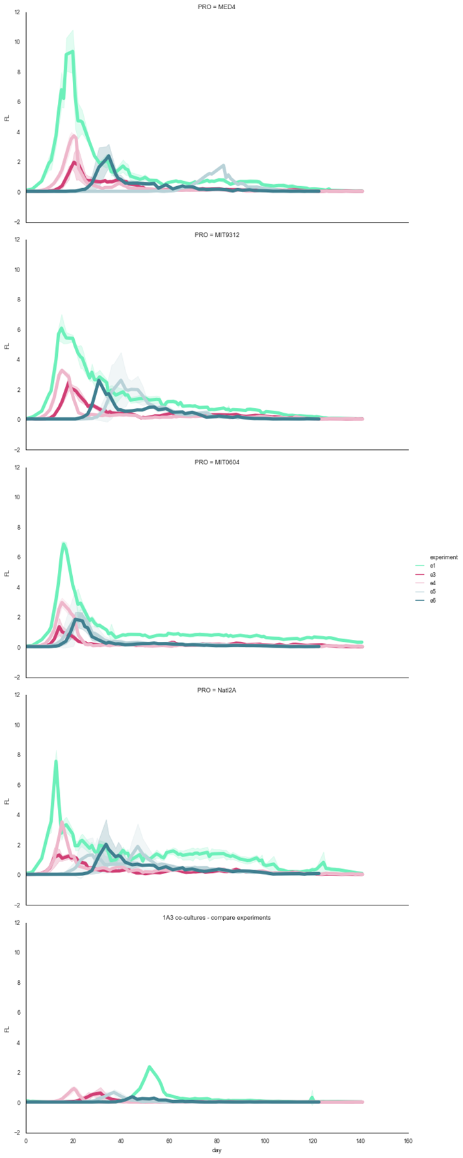

* 1. There are still differences between Pro strains and not between Alt – 9313 and 0604 most similar. show PCA? Use Random forests here?

**PCA – experiment3,4 – experiment 1**

**AUC?**

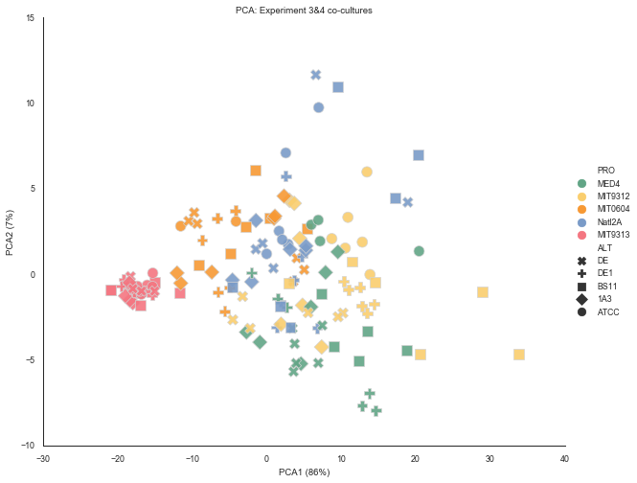

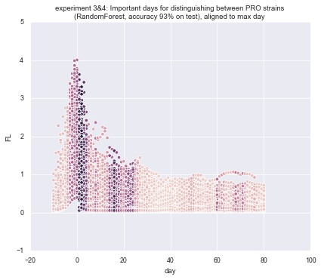

* 1. There are also differences in the number of cells (FCM data – should it go here?)

1. What are the aspects of the growth/decline that differentiate between the Pro strains?
   1. There are differences between transfers after 100 (3,4) and 140 (5,6) days (the 120 days “change”)

**PCA, feature bars**

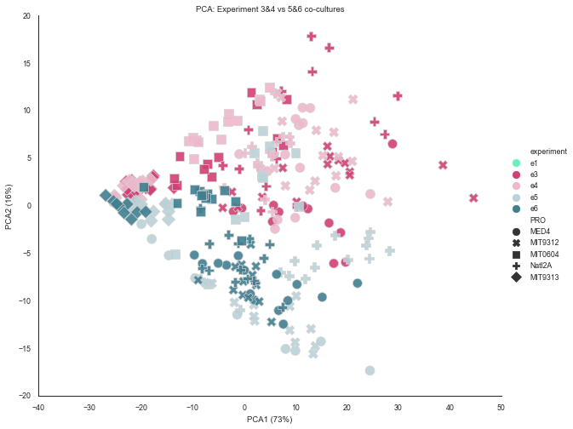

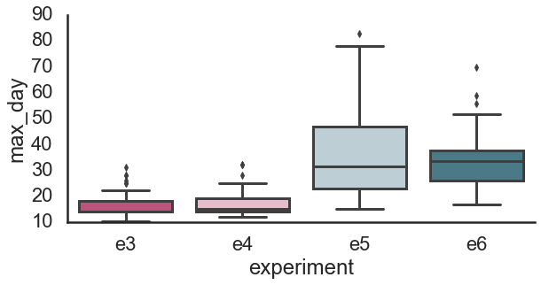

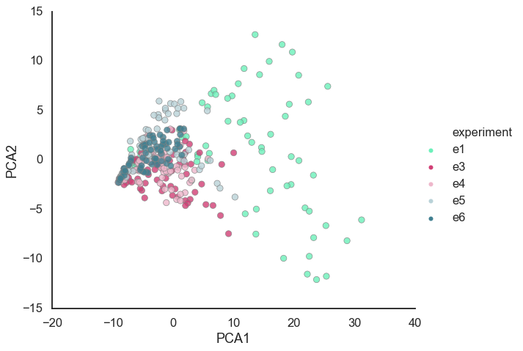

* 1. 9313, 0604 decline faster. Others have “bumps” (knees). These bumps are seen (to some extent) also in axenic cultures

**??**

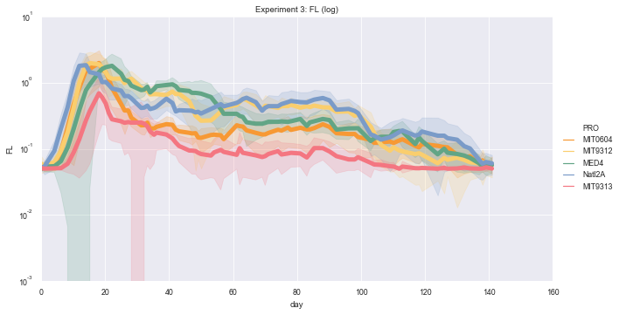

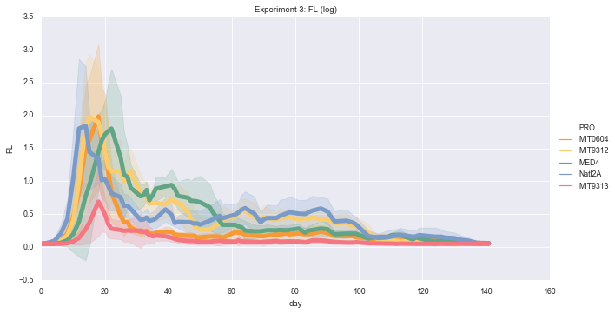

* 1. The bumps are related to changes in cell number (or is it fluorescence/cell? Look at the 9312 experiment and the correlations Osnat did between cell numbers and FL across experiments).

1. What are the mechanisms? We have several hypotheses
   1. Nutrient recycling (read Joseph paper, get NO3 measurements)
   2. Genetic adaptation (get re-sequencing results)
   3. Fit a model?